Beat the Eagle Scout Challenge

Central Georgia Council Camporee

September 18-20, 2026
Lake Tobesofkee, Arrowhead Campground
Scouts BSA
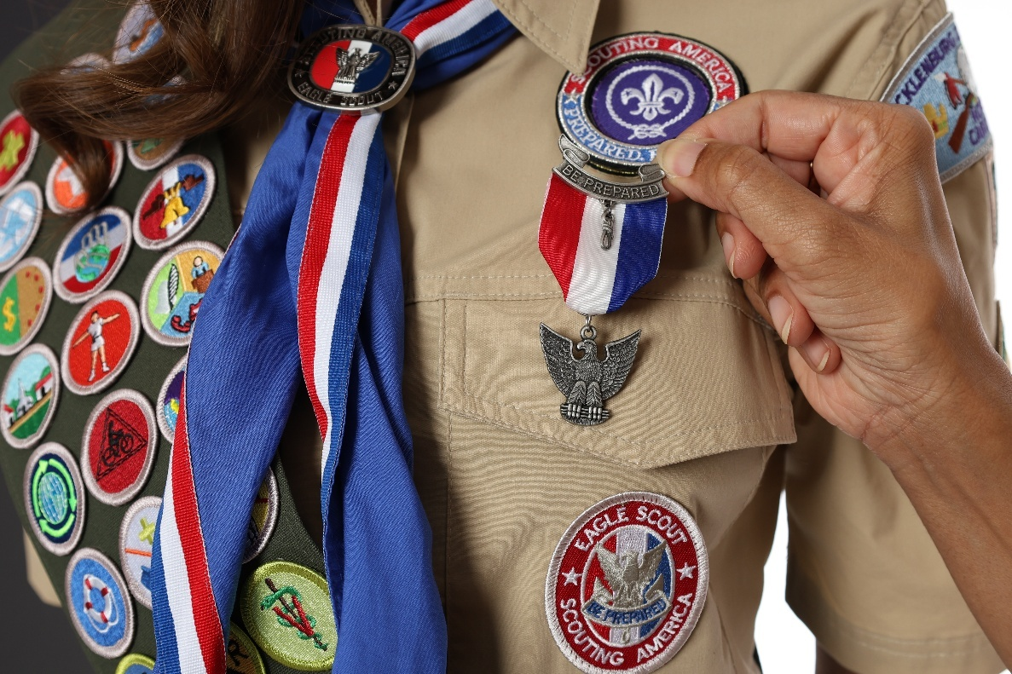
CAMP-O-REE

Leader Guide
Revision 1

Contents
Welcome 4
General Information 4
Registration 5
Camp Information 5
Check In Procedure 5
Campground Facilities 6
Check Out Procedure 6
Program Information 7
Camporee Schedule 7
Beat the Eagle Scout Challenge 8
Camporee Tips and Hints 8
Transportation: The Scout “Trailer” 8
Campfire Program 9
Saturday Activities 9
Camporee Map 13
Patrol Roster 14
Score Sheets 15
Klondike Derby Trailer Inspection Sheet 16
Hoist the Flag Scoresheet 17
Whiteout Scoresheet 18
Avoid the Freeze Scoresheet 19
Blocked Trail (Log Lift and Saw) Scoresheet 20
Mentally Awake Challenge Scoresheet 21
Turkey Shoot Scoresheet 22
Blizzard Shelter Scoresheet 23
Water Reserves Scoresheet 24
Search and Rescue Scoresheet 25
Ka-Boom Scoresheet 26
Flash Flood Scoresheet 27
Soggy Bottom Regatta Scoresheet 28

Revision History
2026-03-14 Initial Issue
NOTE: This Guide will be updated and reissued at least once prior to camporee. If you have any questions regarding this leader guide please contact Anna Lilley, annalilley@hotmail.com, (478) 542-4403.

Welcome
Welcome to Central Georgia Council’s 2026 Camporee! This year the theme is Beat the Eagle Scout Challenge. As you’ll see in this Guide, our team has worked hard to provide Camporee participants traditional Scouting program events, with activities designed so that Scouts of all levels will have a memorable experience. All Camporee details can be found in this Leader’s Guide; however, we anticipate at least one update prior to the event.

This camporee is planned and conducted by adult and youth volunteers. Proper staffing for the event is critical to its success, and we need your help. If you have Scouts (ages 15+, Star Rank+) or registered adult leaders who would like to staff, please contact us. All units are asked to identify one adult or older Scout to help run a program station. Lack of staff will significantly impact the program.

As a reminder, Scouts BSA and Venturing are youth-led programs. Unit Leaders are encouraged to give this guide to the unit’s youth Scout Leaders so they can prepare for success.

Yours in Scouting,
The Camporee Team:
- Anna Lilley (annalilley@hotmail.com 478-542-4403), Raymond Carnley, & Amy Eddy

General Information
Location: Camp Arrowhead, Lake Tobesofkee
Arrowhead Dr, Lizella, GA 31052

Cost: $25 per Scout youth
$20 per Adult
Note: Costs apply regardless of the participant’s duration of attendance.

Key Dates: Registration Opens June 1, 2026
Patrol Rosters Due September 14, 2026
Camporee September 18-20, 2026

Meals: Participants – Lunch on Saturday is included; units should plan all other meals.
Staff – Saturday meals and Sunday breakfast are included.

Trading Post: Available for merchandise only (no snacks)

Staff: We are looking for motivated, dedicated, energetic Scouts, Venturers, and Adult Scouters to help staff camp this year. Adults must be registered leaders to participate. Scouts must be at least age 15 and Star rank to participate. If you are interested, please email annalilley@hotmail.com.

Uniforms: Official BSA field uniform shirt (i.e. Class A) is required upon camporee arrival, at Leaders Meetings, Scouts Own service, and at Fri/Sat campfire programs. Scouts may wear Unit t-shirts or activity uniforms (i.e. Class B) for competition events on Saturday.

Registration
Payment and registration is online only, via the Central Georgia Council website https://www.centralgeorgiacouncil.org/.
- Units shall register all member attendees; members should not register individually.
  - Per BSA regulations, two registered adult leaders must attend with each unit.
  - Units may update their online registration until September 14th, 2026.
- Medical forms (Parts A & B) are required for all attendees.
  - All unit forms are required at check-in, no exception.
  - Forms will be returned to the unit at Check-out.
- Patrol Rosters shall be completed and emailed to annalilley@hotmail.com by Sep. 14th.
  - Patrols will consist of 2-9 Scouts, identified by name/rank on the Patrol Roster.
  - Units may have multiple patrols participate per troop.
- New this year: Cub Scout AoL Dens/Patrols may attend as their own registered unit.
  - Cub Scouting camping rules apply including two-deep leadership and at least one BALOO trained adult.
  - If an AoL’s den is NOT attending as a unit, individuals (accompanied by a parent) may register and attend for the day only, with a sponsoring troop.
    - For assistance connecting with a sponsor Troop, please contact Camporee staff.

Camp Information

Check In Procedure
Units may check-in on Friday from 5:30pm – 7:30pm. One unit leader should report to the registration area to check your unit in and receive all materials (including wrist bands). Saturday check-in will be 8:00am-8:30am. The following materials are required at check-in:
- Unit Medical Forms in a folder/binder.
- Unit Roster with all youth and adult attendees identified.
- Patrol Rosters with youth names/ranks for Camporee activities.
- Annual swim test record, for those participating in aquatics activities.

Note: Please remind parents/guests that all attendees must be registered; anyone without a wristband will be asked to leave.

Campground Facilities
Units will be sharing the group site at Arrowhead Campground at Lake Tobesofkee and the campsites around Hidden Lake.
- Camping
  - Space is limited, please instruct campers to bring as few tents as possible, pitched closely together.
  - Campsite assignments will be made approximately one week prior to the event, emailed to the unit’s registration point of contact.
- Parking/Vehicles
  - Parking is limited and units are requested to carpool as much as possible.
  - Unit trailers/vehicles may drive down to the campsite area to load/unload
  - Trailers may stay at the site.
  - Vehicles must be moved to parking spots after loading/unloading.
- Campfires
  - May be built in designated fire ring areas only.
- Sanitation
  - There are public restrooms throughout Arrowhead Campground, including handicap facilities.
  - Potable water is available at the campground but may have to be carried to sites.
- First Aid & Health Services
  - Come healthy. Everyone should bring a refillable water bottle (put your name on your bottle). Units are responsible for securing medications in their campsites. Wash your hands regularly. Bring insect repellent and sunscreen. Keep bath houses and toilet facilities clean. The group site on Arrowhead at the top of the hill will have a designated medic.
- Security
  - Wristbands are always required. Since this is a public park, it is especially critical for wristband diligence. Those without wrist bands will be asked to leave.
  - Please be courteous to Security Staff and other campers.
  - Please always drive CAUTIOUSLY throughout camp!
  - Scouts must always use the Buddy System.
  - All Youth Protection rules apply.
  - Alcohol, tobacco, fireworks, firearms, and illegal drugs are prohibited.

Check Out Procedure
Do NOT depart until you have checked out with camporee staff.
- Eat Breakfast. Attend Scouts Own service.
- Pack Your Gear. Clean up Campsite.
- Complete campsite inspection with Camporee staff. Get clearance to depart from a Camporee Leader. Receive Patches from designated Leader. Load Vehicles. Depart camp. Reminiscence about Camporee on the way home!

Program Information
The Camporee is an opportunity for Scout Troops, Crews, and Posts to demonstrate their Scout skills and Scout knowledge. It Is meant to be both a competitive event and a fun learning opportunity. A "winning at all costs" attitude is discouraged. As with all Scouting events and activities, the Scout Oath, the Scout Law, and Outdoor Code are the guidelines for behavior.

Camporee Schedule
Friday
5:30-7:30pm Troop Check-in/Camp Set-up
7:00-8:00pm Trailer Inspection (campfire area at Arrowhead)
8:00pm Opening Campfire at Arrowhead - bring a flashlight and blanket/chair
8:45pm Scoutmaster/SPL Meeting (snacks will be provided)
9:30pm Staff Meeting (snacks will be provided)
10:15pm Quiet/Lights Out

Saturday
7:30am Breakfast at campsite
8:45am Opening Flags
9:00am Patrol Competitions
11:30am-12:30pm Grab ‘n Go Lunch any time in this block
12:30pm-2:30pm Patrol Competitions Continue
2:30pm Scout Trailer Time Trials
3:00pm Open Aquatics
4:00pm Field Game and Open Ax Throwing
4:45pm Closing Flags
5:00pm Dinner / Unit Free Time
8:00pm Closing Ceremony at covered group pavilion behind the playground
9:00pm Scoutmaster/SPL Meeting
10:00pm Quiet/Lights out

Sunday
7:30am Breakfast and pack up
9:00am Scouts Own Worship service at Arrowhead
9:30am Campsite inspection/check-out, leave no trace

Disclaimer: Understand that this is a working document, and plans are still in progress. Activities/Competitions may change based on registration numbers/budget and availability of materials and supplies. The agenda and schedule may also be modified to make sure that enough time is given to everyone for the events.

Beat the Eagle Scout Challenge
An Eagle Scout is the highest rank attainable in the Scouts BSA program of Scouting America. Only about 4% of Scouts achieve this honor, which requires earning 21 merit badges, demonstrating leadership, and planning/executing a significant community service project. It represents a lifelong commitment to service, the Scout Oath, and the Scout Law.

We invite Eagle Scouts both old and young to form their own patrol and compete against our local Troops. Patrols will complete challenges at a variety of stations that test their Scout skills and leadership abilities, earning points towards a total score. The patrol must determine and plan what equipment they need and how to transport it from station to station in a homemade “trailer” pushed/pulled by Scout power.

Gear and equipment will not be provided; each Patrol must plan ahead!

Camporee Tips and Hints
The key to a successful Camporee is Plan, Plan, Plan!
- Read through the activities thoroughly; each patrol should plan to bring the materials and equipment they will need.
- Review what to expect at your Patrol Leader Council (PLC), patrol meetings, and troop/crew meetings.
- Be prepared for the weather; review the 10 Essentials.
- For meal planning, keep it simple; be sure to leave enough time to enjoy the camporee activities without spending a lot of time on meal prep and cleanup.
- Be sure to take frequent breaks and plan a rest stop for lunch.

Transportation: The Scout “Trailer”
Each patrol will need a “trailer” to move from station to station. The trailer must be Scout constructed and non-motorized but may be made prior and brought to the event. The trailer should have wheels or otherwise travel in a way that does not damage the ground or property (remember, this is a public campground). The trailer shall carry all the patrol’s gear and equipment for the day. The trailer should be able to carry the “quartermaster” safely while being pushed or pulled by the rest of the patrol.

Patrols should use their “trailers” to transport their equipment from activity to activity. The Patrol Leader is expected to always be in complete control of his/her team and trailer. At no point in the camporee should the safety of others around the trailer be compromised.

As a reminder, adults are not part of a Scout patrol. Adult leaders should not accompany or help pull the trailer and adult participation will result in disqualification. Cheering and encouragement are allowed and encouraged. A Scout Trailer Inspection Sheet is available in the appendix to assist in trailer construction.

Trailer Inspection (Friday Evening)
Present your Trailer for inspection! Points will be given for functionality, use of Scoutcraft skills (built, not bought), and creativity for the most trailer-like construction. Demonstrate how your trailer safely operates, show off your gear, and describe how you designed and built it.

Campfire Program
We do not have arena seating, so Scouts should bring a chair or blanket or be prepared to sit on the ground. Saturday night’s Campfire will be filled with skits/songs presented by both staff and units. Troops that wish to perform a skit, song, joke, etc. at the Campfire may try-out/sign-up during lunch. Please come prepared; we would like all units to participate!

Order of the Arrow Call Out
The Echeconnee Lodge of the Order of the Arrow (OA) will be conducting a Call-Out for the OA at the Camporee Campfire. Please get in touch with your OA representative to ensure that OA elections will be held prior to Camporee to ensure that your scouts are included in the call-out. For more information about OA elections please contact the Lodge Chief Victoria Byrd at lodgechief@echeconnee.org or Lodge Adviser Louis Lilley at adviser@echeconnee.org.

Saturday Activities
Camporee stations and activities are listed below. Unless indicated, each team is responsible for bringing the necessary items to complete each task. Most of the activity stations will be open from 9:00am – 2:30pm, although some stations may pause during lunch.

- Hoist the Flag
A good Eagle Scout knows all about patrol spirit. Bring your patrol flag to the campfire area and lash together a free-standing flagpole, at least 10 feet off the ground. The tallest pole standing by dinnertime is the winner. You will need your own materials, unassembled, when you arrive for this event. Patrols may only use wooden staves and rope to create the flagpole.

- Trailer Driving
Eagle Scouts often graduate into Scoutmasters, who must learn how to tow a trailer and navigate the bumpy roads that lead to a campground. Race against the clock as you navigate your trailer blindfolded through an obstacle course to show your teamwork, communication, and navigation skills. One patrol member may act as a “spotter” from outside of the course. Bring your own neckerchiefs.

- Fire Building Challenge
A campfire can warm you, cook your food, and lift your spirits on a cold morning. Patrols must build a fire and cook a single pancake. The fire must be built using traditional methods, flint and steel, ferrous rods, bow drills, or magnifying glasses. No matches are allowed. Liquid accelerants (lighter fluid, etc.) and mechanical devices such as lighters, torches, or items that create an electrical spark/arc are not permitted, but homemade fire-starters are encouraged. The fire must burn through a rope that is 16” off the ground before you begin to cook your pancake. You should bring your own traditional fire-starting and cooking materials with you, but pre-mixed pancake batter and firewood will be provided.

- Ax Accuracy Challenge
Patrols will participate in a Split the Match challenge. Each patrol will attempt to split 8 matches. Each Scout in the patrol shall get a turn. Patrols with less than 8 Scouts will choose which Scouts go twice. No Scout will go more than twice.

Patrols will line up in relay formation with a chopping block and hatchet. On signal, the first Scout takes up to three strokes with the ax to split the match. When the Scout has taken three strokes (or fewer if they split the match sooner), they tag in the next Scout in line who repeats this procedure. This continues until all Scouts have had a turn, and the patrol has attempted to split all 8 matches.

- Mentally Awake Challenge
Becoming an Eagle Scouts demands a strong mindset, resilience, resourcefulness, and adaptability. While physical strength is important, mental fortitude is equally crucial to overcome challenges, managing risk, and perseverance in the face of hardship. Test your mental skills on a variety of quizzes and puzzles based on information in your Scout Handbook that many Scouts overlook.

- First Aid Challenge
Eagle Scouts are always prepared to help those in need. Bring your patrol’s first aid kit and demonstrate the treatment of injured or sick “patients” using its contents. Patrols should bring everything they need to demonstrate their First Aid skills as identified in the Scout Handbook.

- Ax Throwing Challenge
Patrols will compete with their ax throwing skills. Each Scout will get three practice throws, and then five competition throws. Scoring focuses on accuracy, with a circular target utilizing a ring system (i.e. bullseye, inner ring, middle ring, outer ring, etc.). Scout scores will be averaged to get a patrol score.

- Dining Fly Challenge
A dining fly can shelter your gear and keep you dry. Patrols should bring all the materials they need to assemble a traditional (tarp and stave) dining fly. Metal expandable staves are allowed, but no EZ-Ups or pop-up canopies. Use two half-hitches to attach lines to your dining fly and a taut line hitch to stake out the lines in the ground. Scoring will be based on speed and appropriate use of knots.

- Camp Gadget: Water Transfer
Pioneering, knot tying, and lashing skills are at the core of a Scout’s ability to survive in the wilderness. Each patrol will use their skills to construct four tripods at indicated points. With the tripods as stands, patrols must use PVC pipe to construct an aqueduct to transfer a gallon of water from the starting point to a water bucket. The starting point of the aqueduct must be at least 6’ high. Scoring will be based on time and the amount of water that ends up in the bucket.

Patrols will be provided (3) 10’ sections of 2” PVC pipe cut in half, (1) gallon milk jug completely full of water, (1) bucket, and (1) 12” ruler. Patrols should bring any materials they need to construct tripods.

- Navigate
An Eagle Scout knows how to navigate using a compass. Patrols will navigate a small (less than a football field) course. Patrol members will be asked to follow a predetermined course and to place a numbered stake marked "END" where they end up. Patrols should bring any materials they need to successfully complete this challenge.

Example Course: From the start, go 125' on a compass reading of 94 degrees; then go 137' on a compass reading of 213 degrees; then go 140' on a compass reading of 340 degrees. Mark the “END” with a stake.

Example Scoring: The END marker is 10' from the start on a compass reading 23 degrees. Permissible error (PE) is 20' 1".

Afternoon Activities
- Open Aquatics
Canoe, Kayak, Swim, and Stand-Up Paddleboard (SUP).

- Field Game and Open Ax Throwing
Ultimate Frisbee or Wischixin or other field game. Staff’s choice! The Ax Throwing area will be open for fun (not scoring).

- Trailer Time-Trials
Race your scout “trailer” on a road course. One “quartermaster” must be inside the trailer at all times while the rest of the patrol pushes. Fastest trailer wins!

Camporee Map
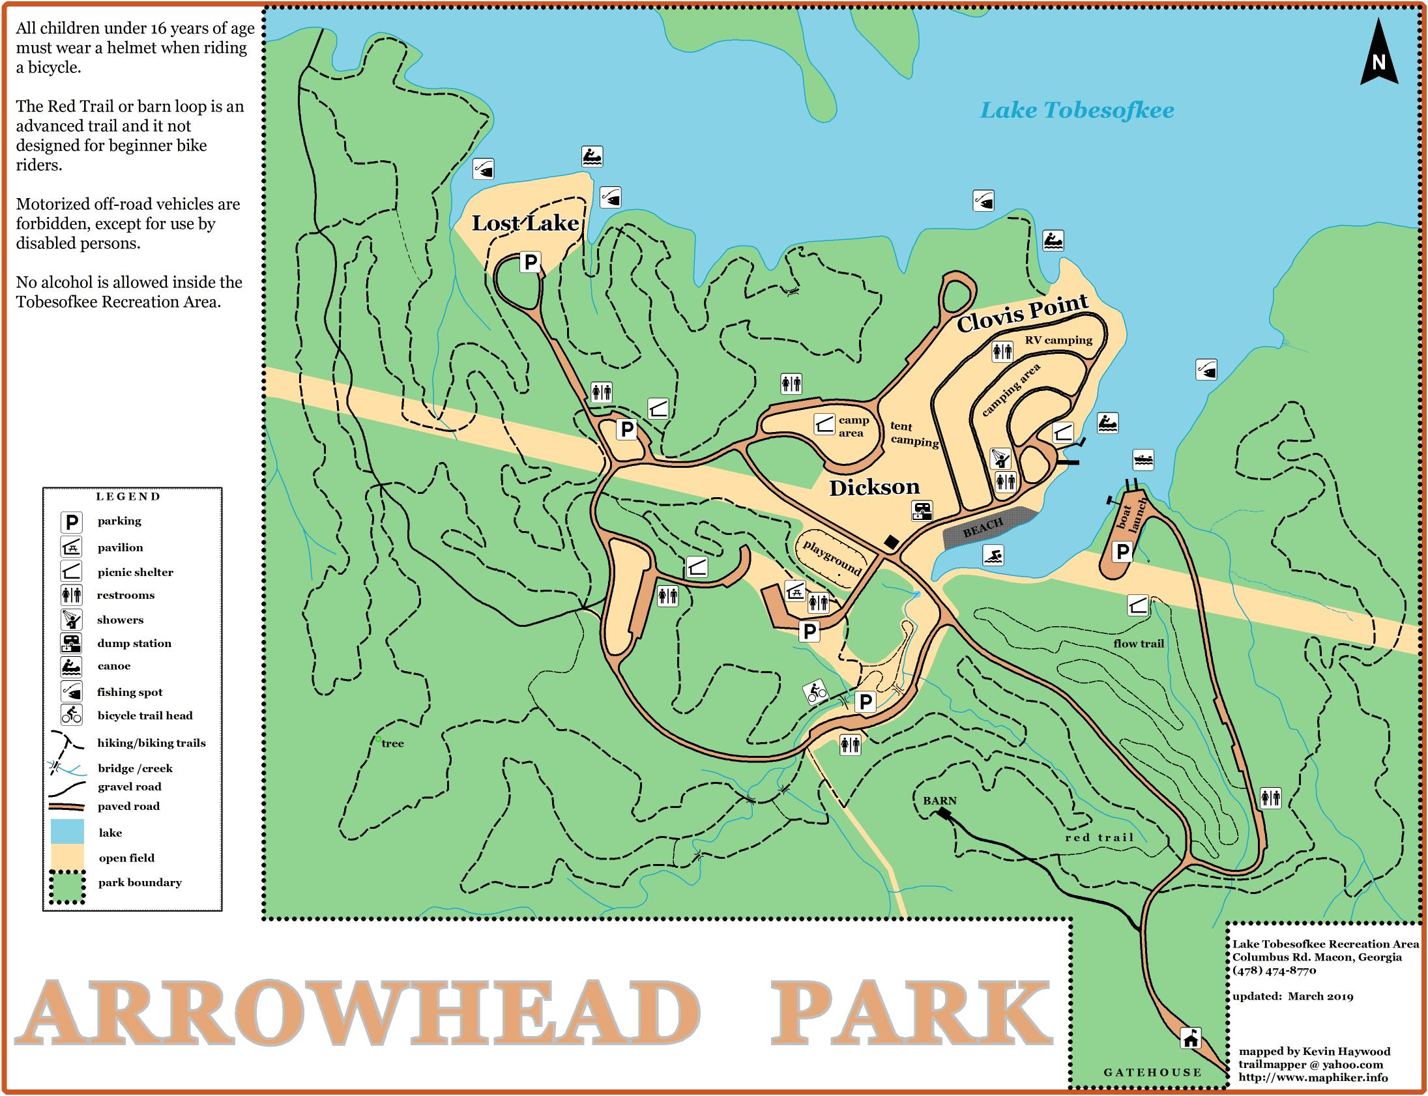

Campfire

- Patrol Spirit – Big Pavillon
- Trailer Driving
- Fire Building – Campfire
- Ax Accuracy – Lost Lake
- Mentally Awake – Big Pavillon
- First Aid -Lost Lake
- Ax Throwing
- Dining Fly
- Water Transfer
- Navigate - Playground
- Trailer Time Trial
- Open Aquatics – Beach
- Field Game - TBD
Big Pavillon

Patrol Roster
Units shall provide one Patrol Roster per patrol, by Sept. 5th.

Patrol Name:
Unit Number:
First/Last Name | Age | Grade | Rank

Score Sheets
The score sheets provided are intended to help patrols identify what equipment they need, what skills they should practice, and what judges expect to see at the Camporee. Each station’s assigned staffer will keep score sheets for all patrols and units that participate. The winners will be announced Saturday evening.

Award Categories:
- Hoist the Flag
- Trailer Driving
- Fire Building
- Ax Accuracy
- Mentally Awake
- First Aid
- Ax Throwing
- Dining Fly
- Water Transfer
- Navigate
- Field Game Champion
- Trailer Time Trial - Top 3 quickest patrols
- Overall Patrol Awards - Top 3 scoring patrols

Trailer Inspection Sheet
Staff Provided Materials: None

This inspection sheet is intended to ensure that all trailers participating in the Klondike Derby are safe, well-equipped, and meet the event standards. Any trailer found unsafe will not be permitted to participate until corrected.

Unit # and Patrol Name:
Patrol Leader Name:
Judge Names:
Judge Comments:

Category | Scoring Criteria | Max Pts | Score
Passenger Capacity | The trailer must fit at least one passenger. | 10
Wheels | The trailer must have wheels or otherwise travel in a way that does not damage the ground. | 10
Safety Features | Trailer is sturdy, no sharp edges, fasteners are secure, adequate push/pull handles, adequate braking or drag, and a passenger can ride safely. | 20
Storage System | The trailer must contain all the patrol’s gear and equipment for the day, with neatness and creativity. | 20
Construction & Design | Creativity for a “trailer-like” vehicle that shows Patrol Spirit! | 20
Demonstration | The Patrol can explain:  How they operate the trailer as a team  How they choose who the passenger is  How they chose their gear/equipment  How they organize the equipment | 20
 | Total | 100

Hoist the Flag
Staff Provided Materials: None

Patrols will work together to build a flagpole and raise their patrol flag.

Category | Scoring Criteria | Max Pts | Score
Construction Techniques | Proper use and execution of Scout skills like lashing and knots, and overall durability. | 25
Functionality | Flag is 10 feet off the ground. | 25
Height | Tallest Flapole (by closing) | 50
 | Total | 100

Unit # and Patrol Name:
Patrol Leader Name:
Judge Names:
Judge Comments:

Trailer Driving Scoresheet
Staff Provided Materials: Obstacle Course

Patrols will work together to navigate a trailer obstacle course.

Category | Scoring Criteria | Max Pts | Score
Construction Techniques | Trailer efficiently completes the course without falling apart or needing repairs. | 50
Time | Points based on completion time and ranked against participating patrols. | 40
Patrol Spirit & Teamwork | Clear display of teamwork, collaboration, and Scout Spirit. | 10
 | Total | 100

Unit # and Patrol Name:
Patrol Leader Name:
Judge Names:
Judge Comments:

Firebuilding Scoresheet
Staff Provided Materials: pancake batter (already mixed), one rope 16” off the ground, kindling, and fuel wood

Patrols will be given a safe fire-starting area with kindling, fuel wood, and a rope 16” off the ground. When the judge starts the 30-minute count-down timer, patrols will work to build a fire using tinder and fire-starting materials from their trailer. Patrols should use natural materials only, NO ACCELERANTS (Vaseline, lighter fluid, etc.)! Once the fire has burned the rope, the judge will provide one pancake to the patrol leader. Once the pancake is cooked, patrols will bring the pancake to the judge for inspection and permission to eat. The judge will stop the timer when the pancake is eaten.

Category | Scoring Criteria | Max Pts | Score
Timed Score | Points out of 30, ranked based on all patrol times. | 30
Method | Fire successfully burns through rope, and built by:  - Fire by Friction = 60  - Magnifying Glass = 50  - Fire by Traditional Flint/Steel = 35  - Fire by Ferro Rod or Sparker = 20 | 60
Patrol Spirit & Teamwork | Clear display of teamwork and collaboration, with Scout-like behavior. | 10
 | Total | 100

Unit # and Patrol Name:
Patrol Leader Name:
Judge Names:
Judge Comments:

Ax Accuracy Scoresheet
Staff Provided Materials: matches, chopping block

The patrol will be timed as they attempt to split 8 matches with a hatchet. Each Scout gets three swing/strikes of the hatchet.

Category | Scoring Criteria | Max Pts | Score
Logs | 10 pts for each match successfully split | 80
Safety | Appropriate and safe use of tools including safe carrying, safe handling, and PPE. | 10
Patrol Spirit & Teamwork | Clear display of teamwork and collaboration, with Scout-like behavior. | 10
 | Total | 100

Unit # and Patrol Name:
Patrol Leader Name:
Judge Names:
Judge Comments:

Mentally Awake Challenge Scoresheet
Staff Provided Materials: all materials

Quiz based on information from the Scout Handbook.

Category | Scoring Criteria | Max Pts | Score
Quiz | Scored based on a 10-question quiz. | 100
 | Total | 100

Unit # and Patrol Name:
Patrol Leader Name:
Judge Names:
Judge Comments:

First Aid
Staff Provided Materials: None.

Scouts are given three first aid scenarios and must identify the first aid action/care to provide and show that they have the appropriate materials in their patrol first aid kit.

Category | Scoring Criteria | Max Pts | Score
First Aid Scenario 1 | First Aid Action Identified – 15  First Aid Material in Kit – 15 | 30
First Aid Scenario 2 | First Aid Action Identified – 15  First Aid Material in Kit – 15 | 30
First Aid Scenario 3 | First Aid Action Identified – 15  First Aid Material in Kit – 15 | 30
First Aid Scenario 4 | First Aid Action Identified – 15  First Aid Material in Kit – 15 | 30
Scout Spirit | Clear display of teamwork, collaboration, and Scout Spirit. | 10
 | Total | 100

Unit # and Patrol Name:
Patrol Leader Name:
Judge Names:
Judge Comments:

Ax Throwing
Staff Provided Materials: Range and Throwing Axes

Each Scout gets three practice throws and five competition throws. Competition throws are scored as follows:
Bulls Eye – 20 pts
Middle Ring – 10
Outer Ring – 5

Scores are averaged for the patrol score.

Category | Scoring Criteria | Max Pts | Score
Scout 1 | Score each competition throw | 100
Scout 2 | Score each competition throw | 100
Scout 3 | Score each competition throw | 100
Scout 4 | Score each competition throw | 100
Scout 5 | Score each competition throw | 100
Scout 6 | Score each competition throw | 100
Scout 7 | Score each competition throw | 100
Scout 8 | Score each competition throw | 100
 | Average Scout Scores to get Patrol Score | 100

Unit # and Patrol Name:
Patrol Leader Name:
Judge Names:
Judge Comments:

Camp Gadget: Dining Fly
Staff Provided Materials: None

Patrols use the materials they bring (tarps, ropes, and staves) to setup a dining fly using two half-hitches attached to the dining fly and a taut line hitch to stake out the lines.

Category | Scoring Criteria | Max Pts | Score
Timed Rank | Points out of 50 based on all patrol times | 50
Materials | Proper use and execution of Scout skills with two half hitches on the dining fly, and taut line hitch at the stakeouts. | 20
Patrol Spirit & Teamwork | Clear display of teamwork and collaboration. | 10
 | Total | 100

Unit # and Patrol Name:
Patrol Leader Name:
Judge Names:
Judge Comments:

Camp Gadget: Water Transfer
Staff Provided Materials:
Three 10’ sections of 2” PVC pipe cut in half
One gallon milk jug completely full of water,
One 5-gallon bucket
One 12” ruler

Each patrol will use their skills to construct four tripods at indicated points. With the tripods as stands, patrols must use PVC pipe to construct an aqueduct to transfer a gallon of water from the starting point to a water bucket. The starting point of the aqueduct must be at least 6’ high. Scoring will be based on time and the amount of water that ends up in the bucket.

Patrols will be provided Patrols should bring any materials they need to construct tripods.

Category | Scoring Criteria | Max Pts | Score
Timed Rank | Up to 50 points based on time of all patrols. | 50
Scout Skills | Points given for appropriate use lashing skills | 40
Patrol Spirit & Teamwork | Clear display of teamwork and collaboration. | 10
 | Total | 100

Unit # and Patrol Name:
Patrol Leader Name:
Judge Names:
Judge Comments:

Navigate
Staff Provided Materials: navigation course and markers

Patrols will navigate a small (less than a football field) predetermined course and to place a numbered stake marked "END" where they end up.

Example Course: From the start, go 125' on a compass reading of 94 degrees; then go 137' on a compass reading of 213 degrees; then go 140' on a compass reading of 340 degrees. Mark the “END” with a stake.

Example Scoring: The END marker is 10' from the start on a compass reading 23 degrees. Permissible error (PE) is 20' 1".

Category | Scoring Criteria | Max Pts | Score
Marker Scoring | The End marker is:  <1 ft from the End location = 90  <5 ft from the End location = 80  <10 ft from End location = 60  <25 ft from End location = 40  <50 ft from End location = 20  => 50 ft from End location = 10 | 90
Patrol Spirit & Teamwork | Clear display of teamwork and collaboration. | 10
 | Total | 100

Unit # and Patrol Name:
Patrol Leader Name:
Judge Names:
Judge Comments:

