Echeconnee Lodge 358
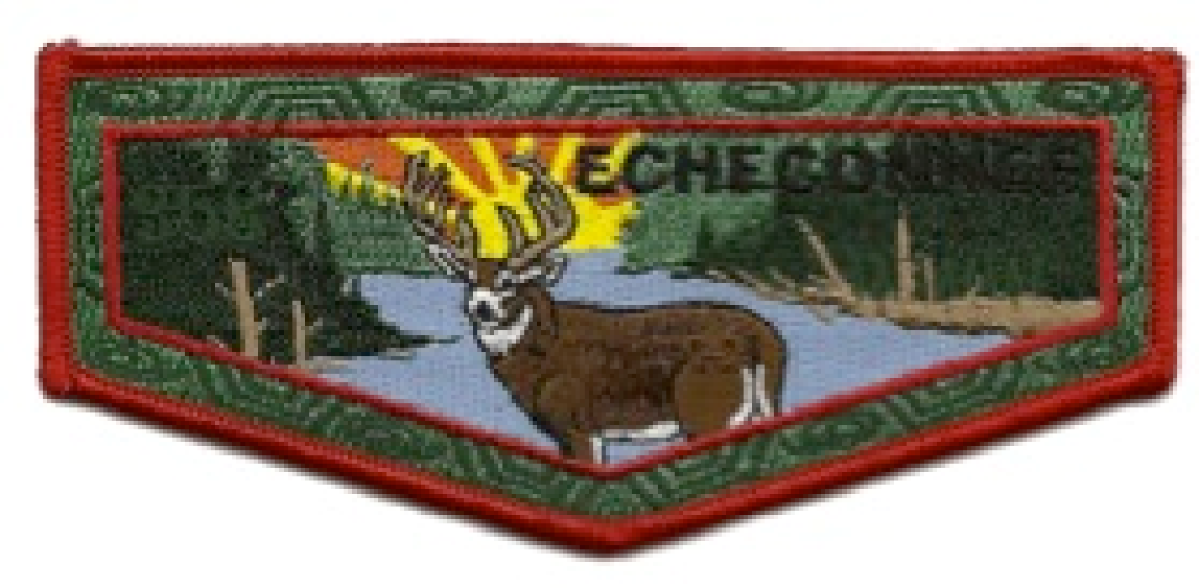
2024-2025 Calendar (draft as of May 4, 2023)

January 2024
5-7 E6 Indian Winter, Camp Bert Adams, Covington, GA
7 LEC meeting – Zoom, 4:00PM
20 Lodge Banquet, 6 PM, Location TBD

February
3 Team Sports/CBH Workday (Plant Trees)
4 LEC meeting – Zoom, 4:00PM

March
1-3 Spring Ordeal/LEC meeting at CBH

April
7 LEC meeting – Zoom, 4:00PM
19-21 E6 Conclave, Camp Thunder, Molena, GA

May
5 LEC meeting – Zoom, 4:00PM

June
2 Workday at CBH to prepare camp for summer programming

July
TBD High Adventure Activity
TBD Fishing/Water Day/Camp Mani Pines Workday
29 – 2 Aug NOAC, University of Colorado, Boulder, CO

August
4 LEC meeting – Zoom, 4:00PM
10 Team Activity/CBH Workday
23-25 ACT Conference, COC meeting, Location TBD

September
7 Council Camporee Callout Ceremony, 6-9:00 PM, CBH
13-15 Fall Ordeal/LEC meeting, CBH

October
5 LEC meeting – Zoom, 4:00PM

November
1-3 Fall Fellowship/LEC meeting, CBH
23 Social Event (Rifle/Turkey Shoot)/Workday, CBH

December
6-8 LLD, Location TBD
Arrival 6:00 PM on 1st Depart 12:00 PM on 3rd
26-31 Winter Camp Cracker Barrel, CBH
Date 28th Time 6:30 – 8:00 pm

January 2025
3-5 E6 Indian Winter, Camp TBD by Section E6
5 LEC meeting – Zoom, 4:00PM
18 Lodge Banquet, 6 PM, Location TBD

